**SEMICONDUCTOR DEVICES AND CIRCUITS**

**EEE2002**

**CONTROLLING 8*8 LED MATRIX USING ARDUINO AND CONTROLLING IT WITH AN ANDROID DEVICE**

**PROJECT PROPOSED AND MADE BY:**

PRATINAV KASHYAP (17BEE1048)

KINJAL GHOSH (17BEE1013)

ANIKET BISWAL (17BEE1053)

PRATIK DAS MOHAPATRA (17BEE1147)

GUIDED BY: PROF. LAVANYA V



**INTRODUCTION**

Development of technology has bought us to such a level that every device and machines is to be controlled digitally. This has led human civilization to think about new ideas and connecting separate devices to create a new one.

Arduino is such a software which has rose to fame because of its dynamic uses. It is an open source computer hardware and software company, project, and user community that designs and manufactures [single-board microcontrollers](https://en.wikipedia.org/wiki/Single-board_microcontroller) and [microcontroller](https://en.wikipedia.org/wiki/Microcontroller) kits for building digital devices and interactive objects that can sense and control objects in the physical and digital world.

8*8 LED matrix as evident from the name is interconnection of 64 LEDs in proper arrangement which is discussed later in the report.

As it was previously mentioned that people are becoming more and more tech-saavy, so the app developers are trying to connect everything to their smartphones. Nowadays, smartphones can do almost every possible actions which were never even thought of.

So we prepared this project to control the LED matrix using our android devices and make our own useful patterns.

OUR PROJECT

**AIM -** To connect and control a 8*8 LED matrix from an Android device using Arduino Uno

**EQUIPMENTS REQUIRED –**

|  |  |  |  |
| --- | --- | --- | --- |
| SL. NO. | COMPONENT | RANGE | QUANTITY |
| 1. | ARDUINO UNO BOARD | - | 1 |
| 2. | IC | MAX7219 | 1 |
| 3. | RESISTORS | 10kΩ, 200Ω | 1, 8 |
| 4. | CAPACITORS | 0.1µF, 10µF | 1 each |
| 5. | BLUETOOTH MODULE | HC-05 | 1 |
| 6. | ANDROID PHONE WITH APP INSTALLED | - | - |
| 7. | PROTOTYPING BOARD | - | 1 |
| 8. | BREADBOARD | - | 1 |
| 9. | LED |  | 64 |
| 10. | SOLDERING IRON |  |  |
| 11. | CONNECTING WIRES |  |  |

**PROCEDURE –**

1. **MAKING THE 8*8 LED MATRIX:**

LED matrix is a grid of lights arranged into rows and columns. LED stands for Light Emitting Diode, so like with other diodes, electricity flows through it in only one direction – from anode(+) to cathode(-); doing so illuminates the light.

By arranging the anodes (positive side) and cathodes (negative side) in a particular way, we can achieve a matrix and call upon each LED individually by sending high and low signals from our arduino device.

Led matrices come in two arrangements. Common-row anode (left) and common-row cathode (right).

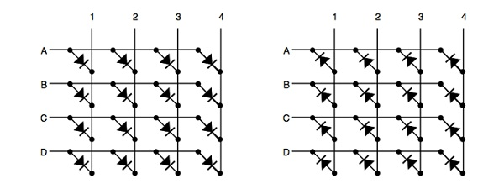

The difference between these two configurations determine how you would call on a specific LED. With common-row anode (left), the current sources (positive voltage) are attached to rows A – D. Currents sinks (negative voltage, ground) are attached to columns 1 – 4.

Conversely, with common-row cathode (right) the current sinks (negative voltage, ground) are attached to rows A – D and currents sources (positive voltage) runs through columns 1 – 4.

Applying this knowledge, to light the top-right LED (A,4) in a common-row cathode matrix you would feed positive voltage to column 4 and connect row A to ground.

For our project, we would be using 8*8 Led matrix . However the arrangement type would be the same, only with 8 rows and 8 columns.

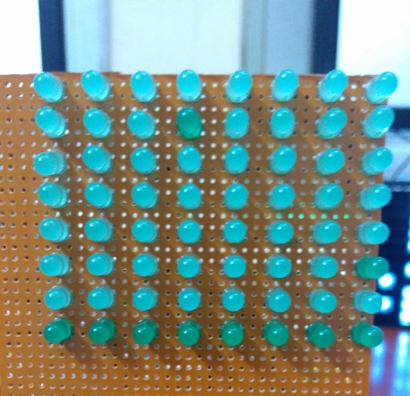

OUR LED MATRIX

1. **MAKING ARDUINO LED MATRIX INTERFACE**

The project is based on the Arduino Uno microcontroller board. Out of the 14 available digital input / output pins on the Arduino Uno, we need only three pins to implement this project.

One pin provides the clock signal to the LED display driver IC (MAX 7219) while another pin is used to transmit the serial data to the IC for displaying on the LED matrix. The corresponding pins must be appropriately mentioned in the program.

3 of the 14 available digital input / output pins are used to control the display driver IC MAX 7219. The 3 pins on the MAX7219 IC are clock, data in and load (or cs in case of MAX 7221 IC). A maximum clock frequency of 10MHz can be applied. DIN (Data in) accepts the serial data from the microcontroller or Arduino board.

It is 16 bit long where the first 8 bits (D0 – D7) are for driving the columns (SEG A-G and DP of the MAX 7219 IC) of the LED matrix and the next 8 bits (D8 – D15) are for driving the (DIG 0-7 of the MAX 7219 IC) rows of the LED matrix.

The load pin (or CS or chip select pin in case of Max 7221 IC) latches the serial input data on its rising edge.

Another important pin on MAX 7219 is the ISET, which sets the peak current to the segment to drive all the LEDs. It is connected via a resistor (R1), which is called RSET. The capacitors filters out any noise in the supply.

When the serial data in is sent using the Arduino (through the program), the serial data is converted into segments and digits to drive columns and rows of the LED matrix. According to the data sent, the corresponding LEDs on the matrix light up and display the message.

The program written here is for scrolling text display. It might be difficult to view long scrolling data on a single 8 x 8 LED matrix. Hence, multiple LED matrices can be chained to form a long matrix.

The no. of MAX 7219 ICs are equal to the no. of 8 x 8 LED matrices. In order to extend the display to multiple LED matrices, the Data OUT (DOUT) pin of the first MAX 7219 must be connected to the Data IN (DIN) pin of the second MAX 7219 IC.

Given below is a small portion of the code which is responsible for the Arduino Led matrix interface:

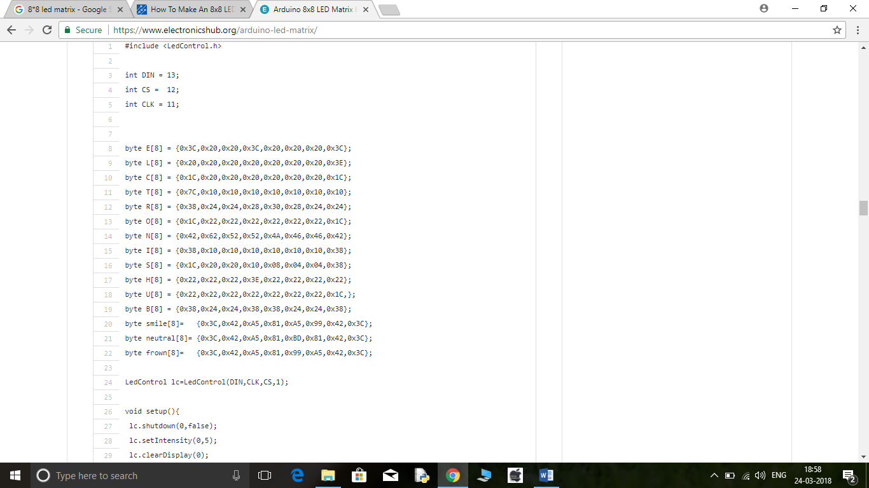

**NOTE**

* The program uses a library called LedControl. This library must be added to the Arduino IDE and the header file LedControl.h must be included in the program.
* The use of this library file is to enable multiple MAX 7219 ICs to be integrated and also provide scrolling text.

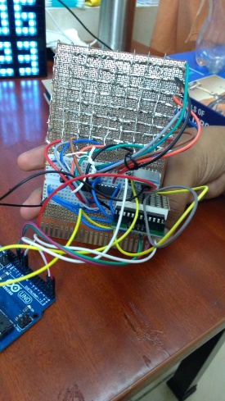

1. **ARDUINO LED MATRIX INTERFACE WITH ANDROID PHONE**

The second circuit in the Arduino 8×8 LED Matrix Interface series is based on Bluetooth Communication and Android Phone. In this project, we have interface Arduino with an Android phone using Bluetooth Communication and the 8×8 LED Matrix connected to Arduino through MAX7219 is controlled through a dedicated application on the Android Phone.

Since the communication between Arduino and MAX7219 is based on SPI Communication Protocol, all we need is three pins from Arduino (Data, Clock and Chip Select). The CS, CLK and DIN pins of the MAX7219 IC Board are connected to pins 10, 11 and 12 of the Arduino.

As we are using the Bluetooth connection between Arduino and Android device, the RX and TX pins of the HC-05 Bluetooth Module are connected to TX and RX pins of the Arduino (Pins 1 and 0).

A dedicated app for Android based devices is designed for this project. The app has 8×8 squares (each corresponding to one LED on the 8×8 LED Matrix), a Reset button and a Disconnect button. Touching a particular square will turn ON the particular LED in the 8×8 LED Matrix.

The color of the square will turn Red, as an indication that the LED is turned ON. Touching the square once again will turn OFF the corresponding LED and the color of the square will revert back to grey.

A Reset button is given at the bottom, using which you can reset the 8×8 LED Matrix i.e. all the LEDs will be turned OFF. The disconnect button will get disconnected from the Bluetooth.

Given below is the small portion of the code to connect the interface to Android device using the dedicated app:

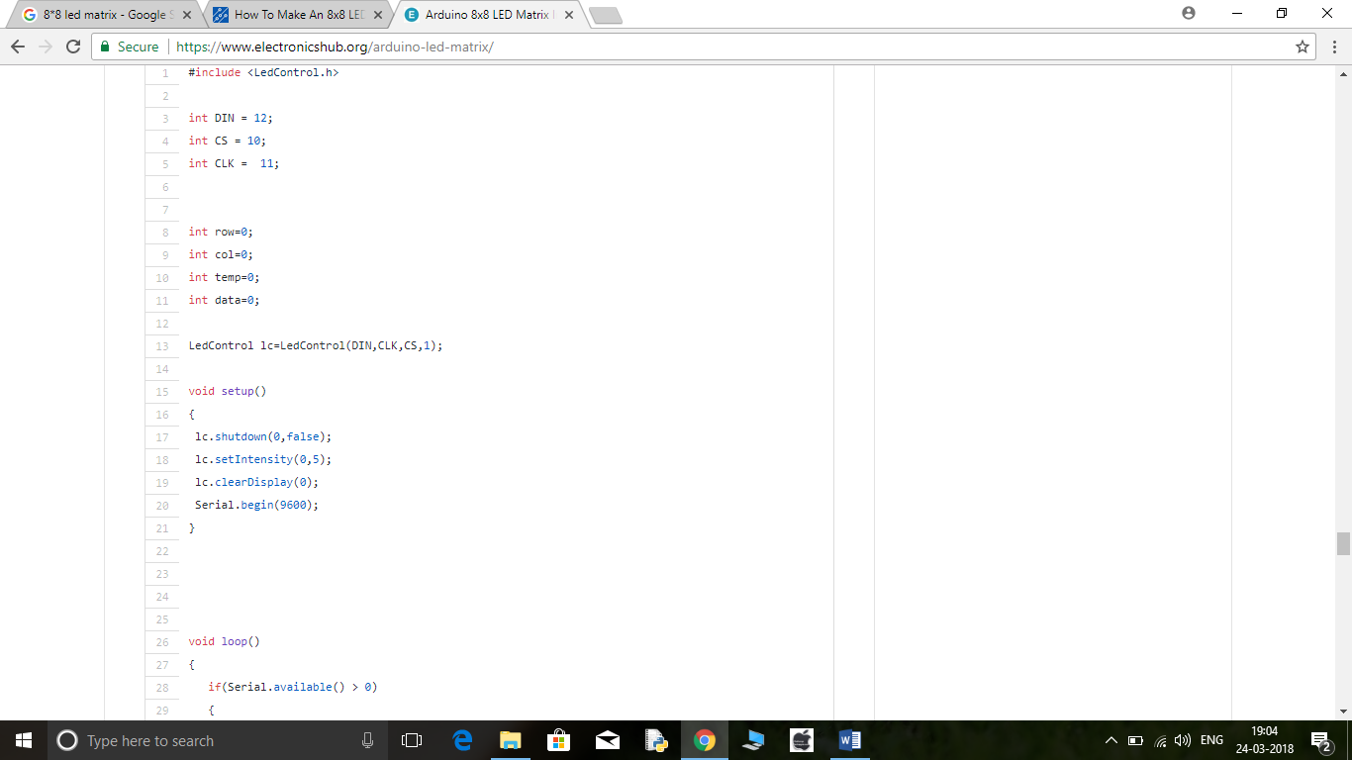

**APPLICATIONS :**

* Arduino based 8 x 8 LED matrix display uses only 3 pins of the Microcontroller. Hence, it can be used in applications where displaying information is a part of the system in which other pins of the microcontroller can be used for other peripherals.
* LED Matrix is a basic form of display device that is used for displaying information at public places like bus or train stations.
* Multiple LED matrices can be combined to form large displays and can be used to display images with multi colors.

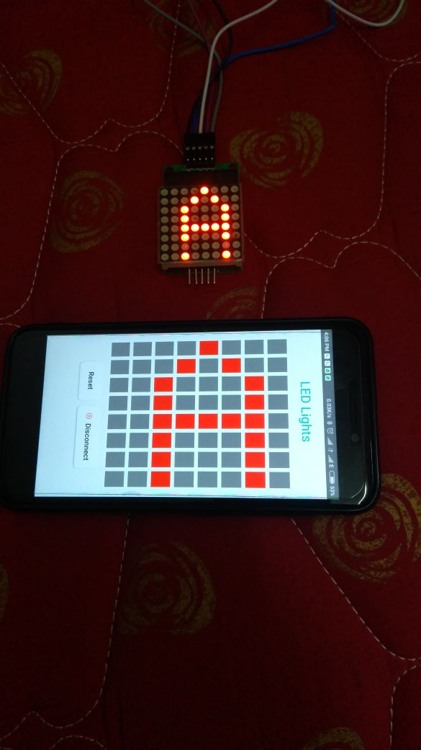 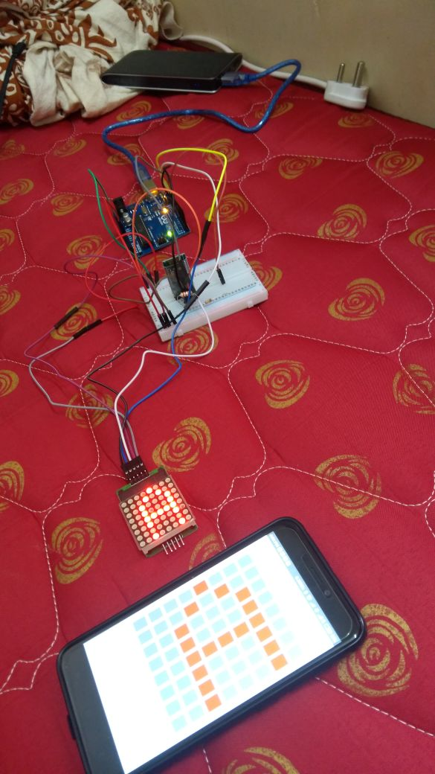

**OUTPUT OF OUR PROJECT WITH READYMADE 8*8 LED MATRIX FOR TESTING**

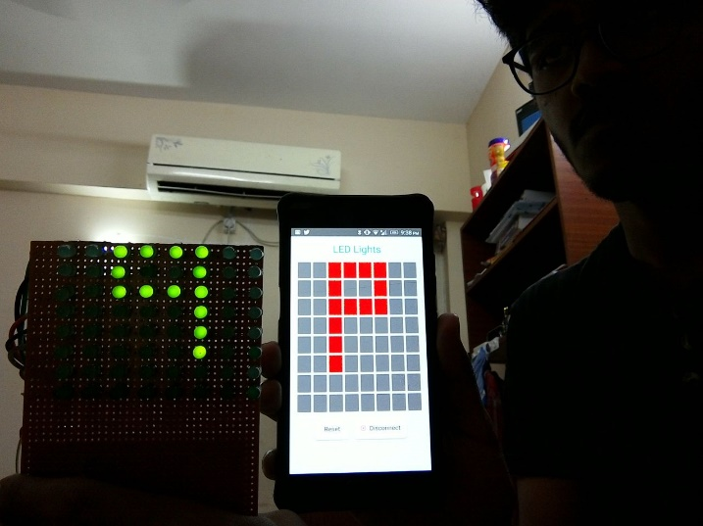 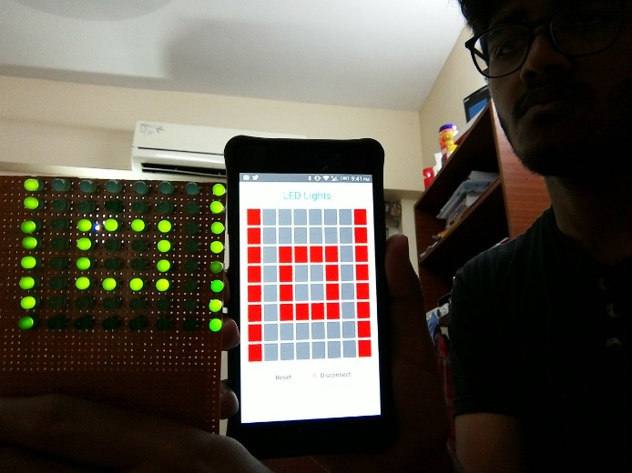

**FINAL OUTPUT OF OUR PROJECT**